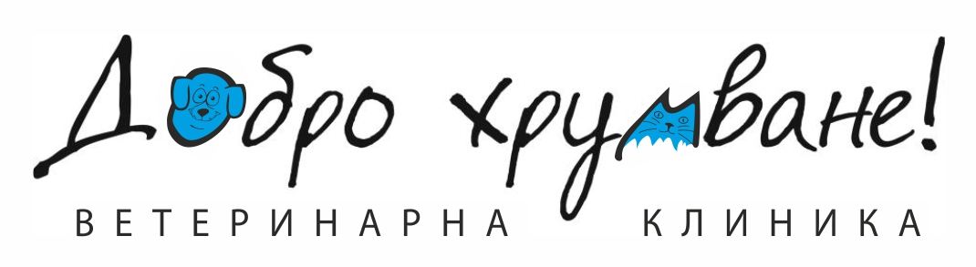
Veterinary clinic „Dobro hrumvane!®”
(Good Idea)
Sofia 125 “Kniaz Boris I” str
Tel/fax: +359 2 929 80 29,cell: +359 896 604 835
Sofia 10 “Poduevo” str
Cell: +359 896 604 836
http://dobrohrumvane.com
dobrohrumvane@abv.bg

Female cat, mixed breed, name: Zapetaika.

The cat was admitted on 24.06.2013 and was discharged on 30.07.2013.

Hospitalization: 37 days (the day of admission and the day of vaccination were not charged) = 245 leva.
Medications: 76,02 leva.
Deworming: 25,88 leva.
Vaccine: 25 leva.
Veterinary diet cat food: 16,10 leva.

Total amount due: 388 leva.
Amount paid: 350 leva. (300 leva paid by Gergana Nikolova)
Total amount left: 38 leva.
Amount paid off by Eli Mantovska on 17.08.2013: 38 leva

